
San Francisco Bay University

CE450 Fundamentals of Embedded Engineering
Lab 5 Driving 7-Segments LEDs

Objectives:
In this lab, the display for some numbers and alphabets will be designed by using several 7-segments LEDs on the Raspberry Pi board through Python program and do hands-on exercise through lab assignments

Introduction:
Two 7-segments LEDs are available in Sunfounder accessory box. The control circuit has been shown using 74HC595(8-bit shift registers) to drive only one 7-segments LED in the following schematic. Three control signals generated from three pins in GPIO port are shifted into 74HC595.

Equipment:
The equipment you require is as follows:
- Laptop & Raspberry Pi 3 model Board
- SunFounder Super Starter Kit V2.0 for Raspberry Pi

The Laboratory Procedure:
- Hardware connection

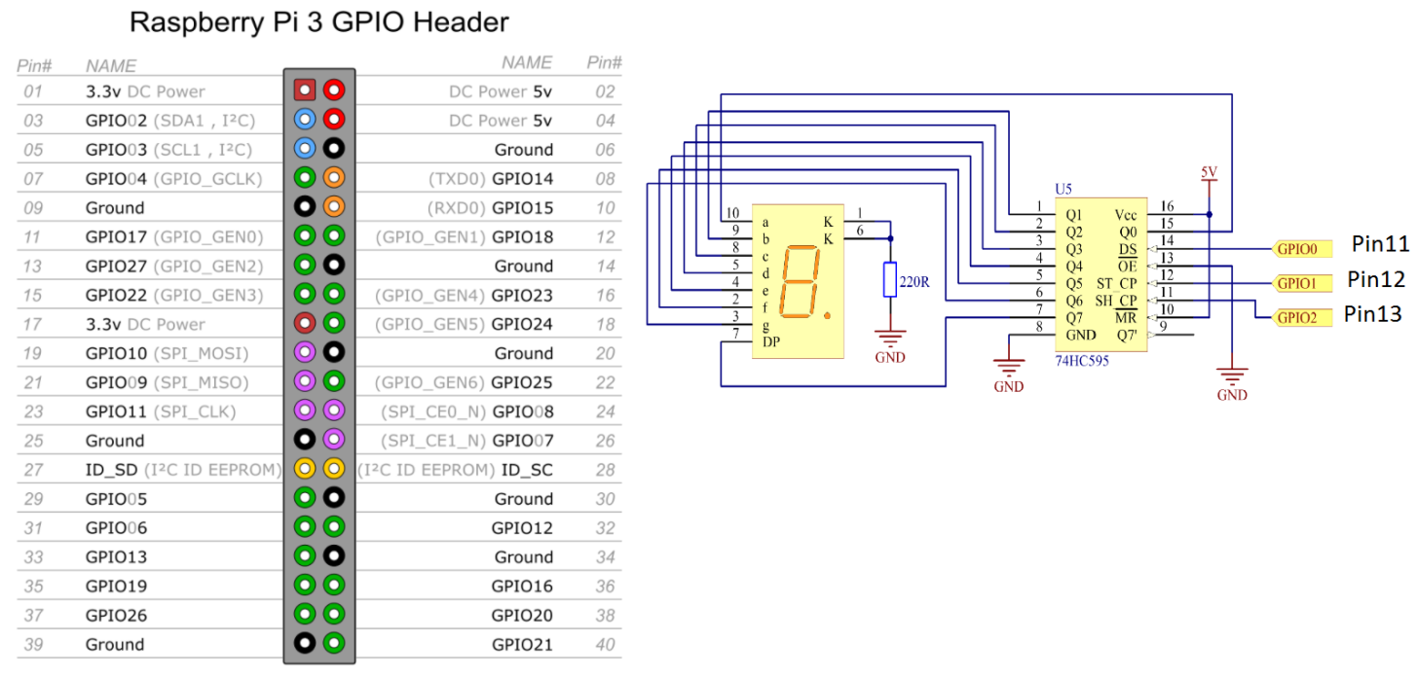
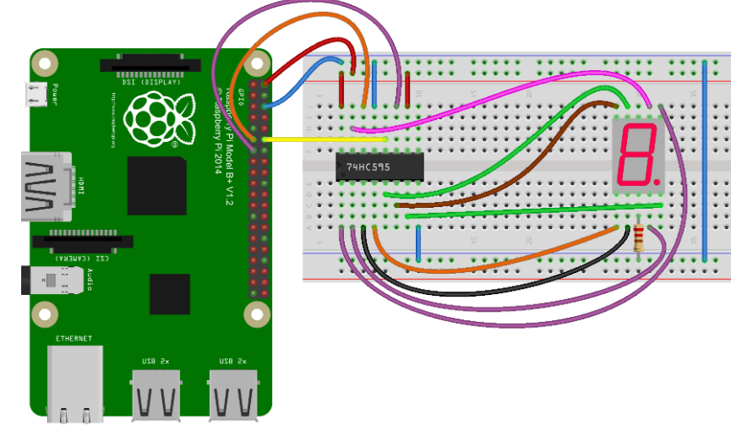

- Control program in Python

# Python program
import RPi.GPIO as GPIO
import time

SDI = 11
RCLK = 12
SRCLK = 13

segCode = [0x3f,0x06,0x5b,0x4f,0x66,0x6d,0x7d,0x07,0x7f,0x6f,0x77,0x7c,0x39,0x5e,0x79,0x71,0x80]

def print_msg():
print 'Program is running...'
print 'Please press Ctrl+C to end the program...'

def setup():
GPIO.setmode(GPIO.BOARD) #Number GPIOs by its physical location
GPIO.setup(SDI, GPIO.OUT)
GPIO.setup(RCLK, GPIO.OUT)
GPIO.setup(SRCLK, GPIO.OUT)
GPIO.output(SDI, GPIO.LOW)
GPIO.output(RCLK, GPIO.LOW)
GPIO.output(SRCLK, GPIO.LOW)

def hc595_shift(dat):
for bit in range(0, 8):
GPIO.output(SDI, 0x80 & (dat << bit))
GPIO.output(SRCLK, GPIO.HIGH)
time.sleep(0.001)
GPIO.output(SRCLK, GPIO.LOW)
GPIO.output(RCLK, GPIO.HIGH)
time.sleep(0.001)
GPIO.output(RCLK, GPIO.LOW)

def loop():
while True:
for i in range(0, len(segCode)):
hc595_shift(segCode[i])
time.sleep(0.5)

def destroy(): #When program ending, the function is executed.
GPIO.cleanup()

print_msg()
setup()
try:
loop()
except KeyboardInterrupt:
destroy()

------------------------------------------------------------------------------------------
segCode = [0x3f,0x06,0x5b,0x4f,0x66,0x6d,0x7d,0x07,0x7f,0x6f,0x77,0x7c,0x39,0x5e,0x79,0x71,0x80]

hgfe_dcba
0011_1111 => 0
0000_0110 => 1
... ...
0110_1111 (0x6f)=> 9
0111_0111 (0x77)=> A
0111_1100 (0x7C)=> b
(0x5A)=> c
(0x5E)=> d
(0x79)=> e
(0x71)=> f
... ... (0x6F)=> g
(0x74)=> h
(0x10)=> i
(0x0E)=> j
(0x70)=> k
(0x18)=> l
(0x49)=> m
(0x54)=> n
(0x5C)=> o
... ... (0x73)=> p
(0x67)=> q
(0x50)=> r
(0x6D)=> s
(0x78)=> t
(0x1C)=> u
(0x62)=> v
(0x36)=> w
(0x52)=> x
(0x72)=> y
(0x43)=> z
1000_0000 (0x80)=> switch-off
*Note: Hardware connection reference and running command
https://learn.sunfounder.com/lesson-14-driving-7-segment-display-by-74hc595/
https://learn.sunfounder.com/category/super-kit-v3-0-for-raspberry-pi/

The Laboratory Assignments:

- Implement the 7-segment LEDs control based on the above example program.

- Add one more 7-segment LED to the above design for the continuous display of the decimal number from 1 to 25 and alphabet from A-Z display, such as the following.
